UNIT-IV:
The principles of abstraction
Encapsulation
Revise these concepts from OOPS theory
Information hiding
Concepts of abstract data type
Modularity
Specification

A Class Responsibility Collaborator (CRC) model (Beck & Cunningham 1989; Wilkinson 1995; Ambler 1995) is a collection of standard index cards that have been divided into three sections, as depicted in Figure 1. A class represents a collection of similar objects, a responsibility is something that a class knows or does, and a collaborator is another class that a class interacts with to fulfill its responsibilities. Figure 2 presents an example of two hand-drawn CRC cards.
Figure 1. CRC Layout.
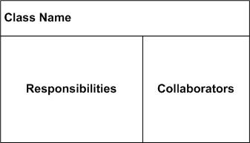
Figure 2. Hand-drawn CRC Cards.
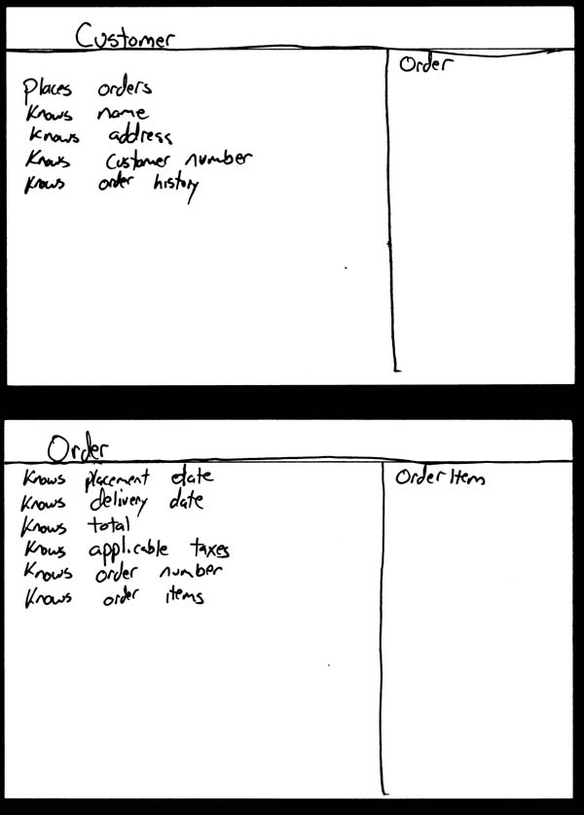

Design Patterns
In software engineering, a design pattern is a general repeatable solution to a commonly occurring problem in software design. A design pattern isn't a finished design that can be transformed directly into code. It is a description or template for how to solve a problem that can be used in many different situations.

Uses of Design Patterns
Design patterns can speed up the development process by providing tested, proven development paradigms. Effective software design requires considering issues that may not become visible until later in the implementation. Reusing design patterns helps to prevent subtle issues that can cause major problems and improves code readability for coders and architects familiar with the patterns.
Often, people only understand how to apply certain software design techniques to certain problems. These techniques are difficult to apply to a broader range of problems. Design patterns provide general solutions, documented in a format that doesn't require specifics tied to a particular problem.
In addition, patterns allow developers to communicate using well-known, well understood names for software interactions. Common design patterns can be improved over time, making them more robust than ad-hoc designs.

Creational design patterns

Structural design patterns

Behavioral design patterns

Creational design patterns
These design patterns are all about class instantiation. This pattern can be further divided into class-creation patterns and object-creational patterns. While class-creation patterns use inheritance effectively in the instantiation process, object-creation patterns use delegation effectively to accomplish the job.
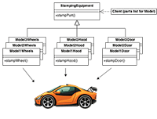
- Abstract Factory
Creates an instance of several families of classes
- Builder
Separates object construction from its representation
- Factory Method
Creates an instance of several derived classes
- Object Pool
Avoid expensive acquisition and release of resources by recycling objects that are no longer in use
- Prototype
A fully initialized instance to be copied or cloned
- Singleton
A class of which only a single instance can exist

Structural design patterns
These design patterns are all about Class and Object composition. Structural class-creation patterns use inheritance to compose interfaces. Structural object-patterns define ways to compose objects to obtain new functionality.
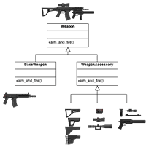
- Adapter
Match interfaces of different classes
- Bridge
Separates an object’s interface from its implementation
- Composite
A tree structure of simple and composite objects
- Decorator
Add responsibilities to objects dynamically
- Facade
A single class that represents an entire subsystem
- Flyweight
A fine-grained instance used for efficient sharing
- 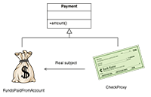
Private Class Data
Restricts accessor/mutator access
- Proxy
An object representing another object

Behavioural design patterns
These design patterns are all about Class's objects communication. Behavioural patterns are those patterns that are most specifically concerned with communication between objects.
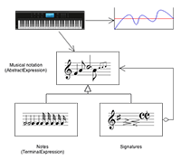
- Chain of responsibility
A way of passing a request between a chain of objects
- Command
Encapsulate a command request as an object
- Interpreter
A way to include language elements in a program
- Iterator
Sequentially access the elements of a collection
- Mediator
Defines simplified communication between classes
- Memento
Capture and restore an object's internal state
- Null Object
Designed to act as a default value of an object
- Observer
A way of notifying change to a number of classes
- 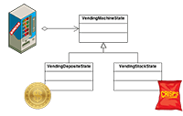
State
Alter an object's behavior when its state changes
- Strategy
Encapsulates an algorithm inside a class
- Template method
Defer the exact steps of an algorithm to a subclass
- Visitor
Defines a new operation to a class without change

